[1]

SOUTH COLOMBIAN UNIVERSITY

ELECTRONIC ENGINEERING

ELECTRONIC ANALOGUE

PRE-REPORT No. 6

TRANSISTORS

Dumar Alexander Delgado Martinez, 20221206321  
Juan Esteban Diaz Delgado, 20212201615

Joan Alejandro Sánchez Rojas, 20221206851

***Summary—*** ***For this laboratory practice, we will work with bipolar transistors, where it is understood that the current flow is established through the different regions of the transistor, this practice is done in order to manage an adequate and essential polarization to ensure that the transistor works efficiently and reliably.***

***Keywords—*** ***Polarization, transistors.***

I. OBJECTIVES

General objetives.

⮚ Acquire practical knowledge and experimental skills that allow them to understand the behavior of bipolar transistors in a circuit and apply this knowledge in future projects and electronic designs.

# Specific objectives

# ⮚ Understand the basic theoretical concepts of the polarization of bipolar transistors and its relationship with the behavior of the transistor.

# ⮚ Become familiar with the use of electronic measurement instruments, such as multimeters, oscilloscopes, and signal generators.

# ⮚ Design bipolar transistor bias circuits in different configurations, such as common-emitter bias and common-base bias.

# ⮚ Perform accurate and reliable measurements of voltages and currents at different points in the circuit using electronic measurement instruments.

# ⮚ Apply the knowledge and skills acquired in the laboratory practice in future projects and electronic designs that involve bipolar transistors

II. THEORETICAL FRAMEWORK

**A. What are BJT transistors?**

Bipolar junction transistors (BJTs) are semiconductor devices used to amplify or switch electrical signals. A BJT consists of three regions of semiconductor material: the base region, the collector region, and the emitter region.

***Image 1. Bipolar junction transistor.***

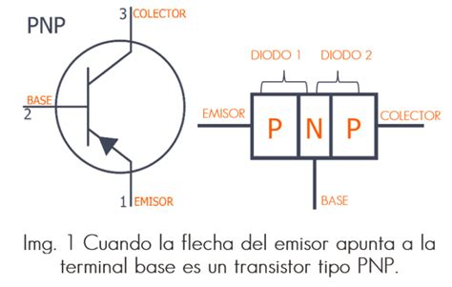

[1]

The base region is the narrowest region and is located between the collector and emitter regions. The collector region is the largest region and is located at the opposite end of the emitter region. The emitter region is located at the end of the transistor that is closest to the base region.

**B. How are BJT transistors made?**

BJTs are constructed in two main types: NPN transistors and PNP transistors. In an NPN transistor, the base region is of P-type and the collector and emitter regions are of N-type. In a PNP transistor, the collector and emitter regions are of P-type and the base region is of N-type.

***Image 2. NPN and PNP transistor.***

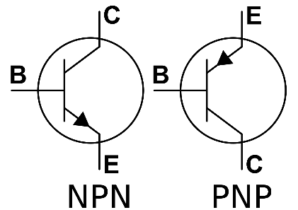

[2]

**C. How is the operation of a BJT transistor?**

The operation of a BJT is based on the base current, which is the current that flows through the base region. When a current is applied to the transistor's base, a current flow is produced between the collector and emitter regions. The transistor is commonly used as a signal amplifier and a switching device.

***Image 3. Operation of the transistor.***

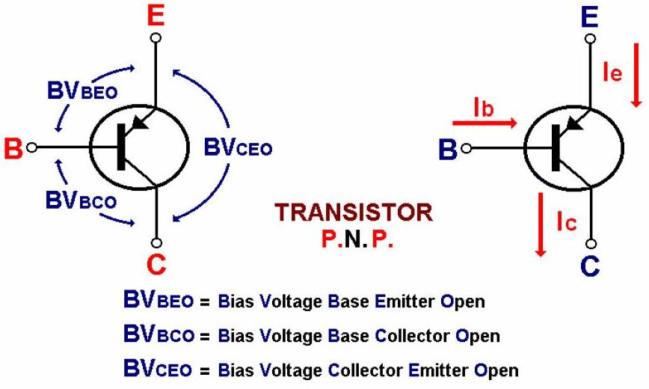

[3]

In an amplifier, the base current is used to control the current flowing between the collector and emitter regions, allowing for amplification of the input signal. In a switching circuit, the base current is used to turn the flow of current between the collector and emitter regions on or off, allowing for electronic devices to be turned on or off.

In summary, BJTs are semiconductor devices used to amplify or switch electrical signals. They consist of three regions of semiconductor material: the base region, the collector region, and the emitter region. BJTs are constructed in two main types: NPN and PNP transistors. They are commonly used in amplification and switching applications and are fundamental to modern electronics.

**D. Where are transistors used?**

BJTs are widely used in modern electronics because of their ability to amplify signals and act as switches controlled by electrical signals. Some components and devices that use BJTs include audio and video amplifiers, radios, televisions, power supplies, motors, fluorescent lamps, speed control systems, electronic switching devices, and signal processing systems.

BJTs are also used in a variety of configurations, including class A, class B, class AB, and class C amplifiers. Each of these configurations has its own characteristics and specific applications.

In addition, BJTs are also used in integrated circuits and in high-frequency devices such as oscillators and radiofrequency amplifiers. They are also used in feedback circuits and in voltage stabilization circuits.

Regarding the construction of BJTs, they are manufactured using diffusion and deposition techniques of semiconductor materials onto a silicon substrate. The materials used include silicon, germanium, and other semiconductor materials. The manufacturing process may include doping layers to adjust the electrical properties of the device.

In summary, BJTs are fundamental components in modern electronics, used in a wide variety of applications ranging from audio and video amplifiers to speed control systems and electronic switching devices. They are constructed using deposition and diffusion techniques of semiconductor materials and are used in a variety of high-frequency devices and configurations.

# III. MATERIAL ELEMENTS AND EQUIPMENT

* 1 endurance of 2,7 kΩ
* 1 resistance of 1 MΩ
* 1 resistance of 33 kΩ
* 1 resistance of 1,8 kΩ
* 1 resistance of 6,8 kΩ
* 1 resistance of 680 Ω
* 1 transistor 2N3904
* 1 transistor 2N2222

IV

A transistor is a semiconductor, used to control very large currents through very low currents, in the same way you can use various types of applications such as a signal amplifier or as a switch, in conclusion this laboratory practice helped the student to improve its performance based on the transistor.

# V REFERENCES

[1] Taken from the web 29/03/2023:

<https://uelectronics.com/transistores-bjt/>

[2] Taken from the web 29/03/2023:

<https://shoptransmitter.com/blog/what-is-the-difference-between-pnp-and-npn/>

[3] Taken from the web 29/03/2023:

http://electronicapractica2012.blogspot.com/2012/06/el-transistor-bipolar-bjt.html

[-] Taken from the web 29/03/2023:

<https://en.wikipedia.org/wiki/Bipolar_junction_transistor>

<https://www.electronics-tutorials.ws/transistor/tran_1.html>

https://learnabout-electronics.org/Semiconductors/bjt_01.php

1.